# EEE109 Lab 2 – Transistors

**Student ID numbers:** *1931254*

**Submission date:** *3/12/2020*

### *Abstract*

*The objectives of the project are: Understand the physical structure and operation of the bipolar junction transistor; make a measurement of the input and output characterisitics of a transistor; design and build a simple common-emitter amplifier. In the project, the approach used is based on control variable method; bulid the circuit; use DMM to regulate the components; measure the outcomes. From the project, we found the input characteristics are that before the voltage reaches a certain value (turn-on voltage), the current changes very little with the voltage; after it reaches a high-speed increase. The output characteristics are that before the voltage reaches a certain value (turn-on voltage), the current increases quickly; after it reaches a low speed. In the project, we fully understood the structure and features of the transistor and have the ability to build a common-emitter amplifier circuit. In conclusion, the project helps us to learn more about the input and output characterisitics and common-emitter amplifier role of the transistor.*

### Background

A bipolar junction transistor is a three-terminal semiconductor device that consists of two p-n junctions which are able to amplify or magnify a signal. The three terminals of the BJT are the base (B), the collector (C), and the emitter (E) as shown in figure 1. The bipolar transistor 2N3904 we will use in this experiment is a typical NPN transistor.

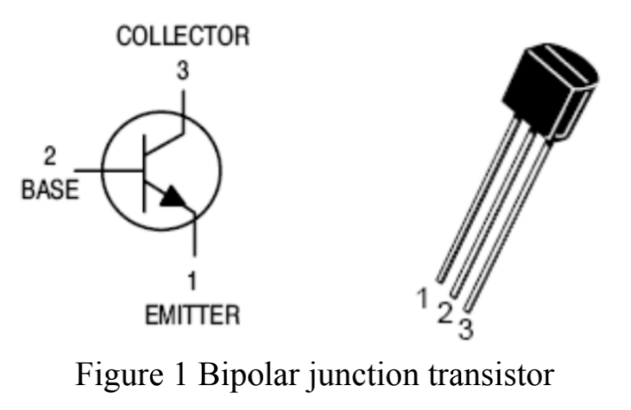

The bipolar junction transistor is one of the most essential semiconductor device because of its three applications which are switch circuits, digital logic circuits, and amplifier circuits. When it is used to amplify current, the transistor is biased in the forward-active mode, where the collector current represents as a function of the base current. The relationship between the collector current and base current is . In this experiment, we will focus on the common-emitter configuration of BJT bias. The base of the BJT serves as the input and the collector serves as the output. The emitter of the BJT is common to both input and output.

### Aims and Objectives

The objectives of the project are:

1. Understand the physical structure and operation of the bipolar junction transistor.
2. Make a measurement of the input and output characterisitics of a transistor.
3. Design and build a simple common-emitter amplifier.

### Experiment/Methodology

3.1 Transistor diagrams and connections

During the whole project, the first thing we should do is establishing the type of transistor we use and the names of each pin. So we used the digital multimeter to check the connections on the given transistor. We connected two of the pins by digital multimeter in a diode mode to see the values on the screen to decide which one is collecter, emitter, or base.

After our measurement, we figured out the connections of the given transistor and got the correct answer of what type it is. Also, we measured the turn-on voltages for the two junctions.

3.2 Input Characterisitics

In this part, we began to measure the input characterisitics of the BJT.

First, we set up a circuit as shown in Figure 2 by using two d.c. power supplies and several resistors and most important bipolar transistor.

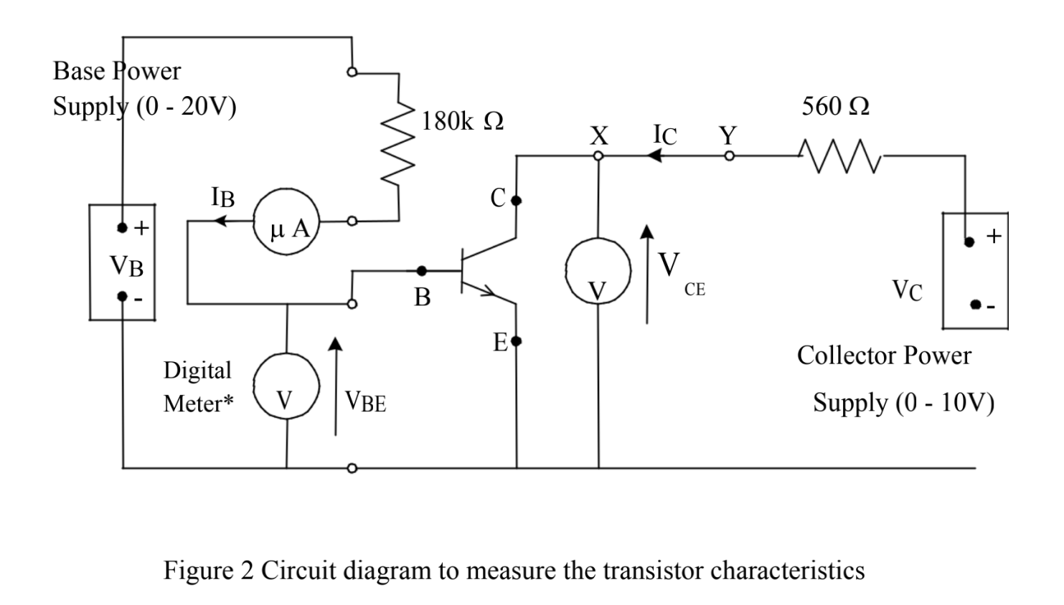

Then we adjusted the base and collector power supply to make

After that, we adjusted to 20,40,70 by scaning the value of to see when it increases rapidly. Finally, based on the values we recorded, we ploted the gragh of against as shown in figure 5.

For the part (b), we set the , repeated the above operation and got another gragh as shown in figure 6.

3.3 Output Characteristics

In this part, we began to measure the output characterisitics of the BJT.

We used the same circuit as shown as figure 2 but changed the place of the digital ammeter to the collector to measure d.c. current. Then we measured by setting to 0.05, 0.1, 0.2, 0.4V etc., in a doubling sequence up to 10V when

Finally, we plotted collector current against collector-emitter voltage for four different base current as shown in figure 7.

3.4 Common-Emitter Amplifier

In this part, we focused on the common-emitter amplifier application of the BJT.

At the beginning, we constructed the circuit as shown in figure 3.

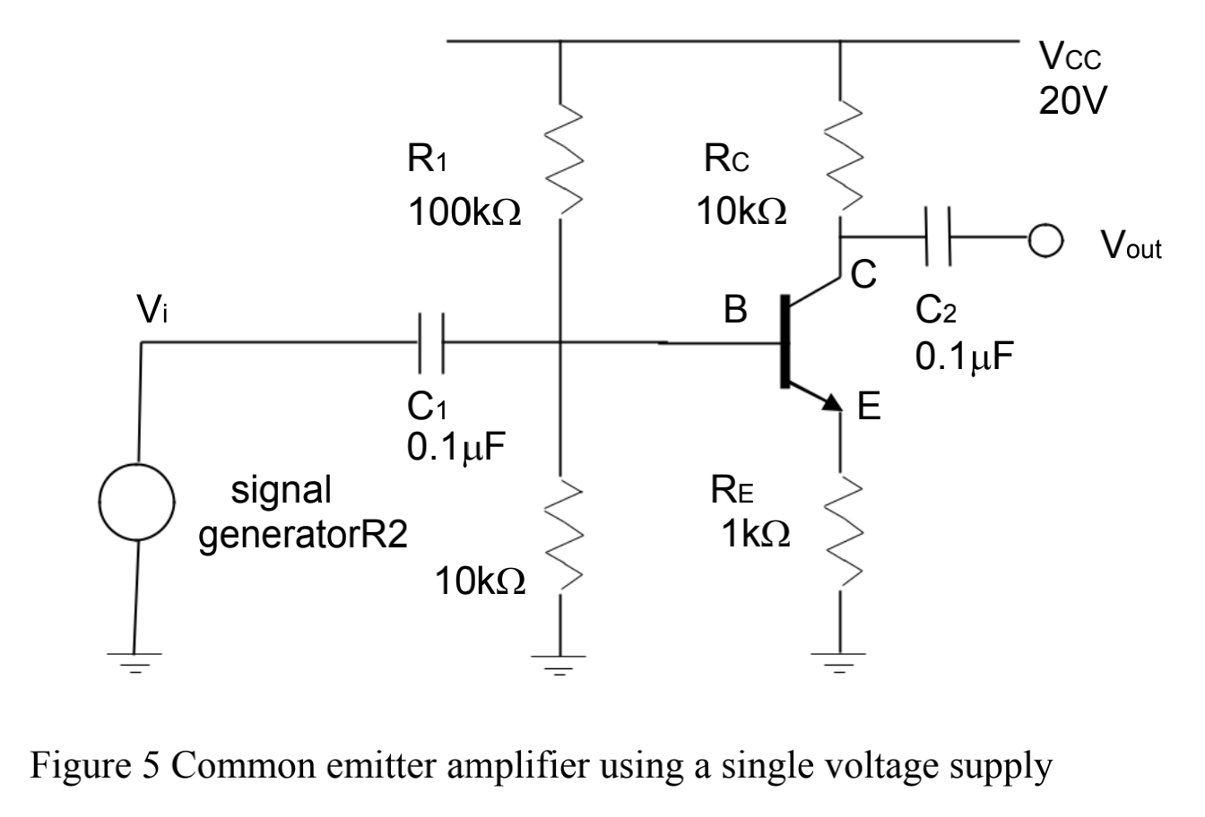

Figure 3 Common emitter amplifier using a single voltage supply

For part (a), we used an oscilloscope to monitor the input and output voltage. And then we made a rough sketch of the waveforms bu using a sinusoidal Vin of 5 kHz and a 0.5V amplitude. At last, we compared the results with the predicted amplification by using the formula Av = .

For part (b), we removed the a.c. input signal and used the digital multimeter to measure . After that, we introduced an ac input signal which is 0.5V amplitude, 5 kHz. We monitored when the Vout becomes clipped or distorted by increasing Vin’s amplitude. During the period, one of us regulated the Vin and the other one watched the screen on the oscollpscope to see whether the waveform begins to clipped.

Finally, we recorded the input voltage when the output voltage became clipped.

### Results

4.1 Transistor diagrams and connections

(a) The diagram of transistor is shown in figure 4.

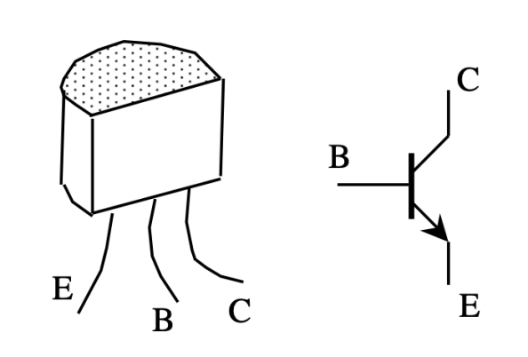

Figure 4 Bipolar junction transistor (NPN type)

The three pins of the given transistor are shown ablove, and the the arrow in the right part of the figure indicates the direction of emitter current.

(b) Based on the measurement of DMM, the transistor is an npn transistor. And the turn-on voltage is 0.65V.

The turn-on voltage of the BJT is , whose value is 0.65V during the experiment.

4.2 Input Characterisitics

For , the gragh of against is shown in figure 5.

Figure 5 plotted against ()

The x axis represents base-emitter voltage (V) and the y axis represents current across base (A).

For , the gragh of against is shown in figure 6.

Figure 6 plotted against ()

The x axis represents base-emitter voltage (V) and the y axis represents current across base (A).

From these two graghs, we found that there is a rapid increase of at around and the values in gragh 2 are not significantly different from those in gragh 1.

This characteristic shows that before achieving the turn-on voltage, there is little current flows across the transistor, and there is no direct relationship between the turn-on voltage and the input voltage. Therefore, the two figures differ little.

4.3 Output Characteristics

The gragh of against is shown in figure 7.

Figure 7 plotted against with different

The x axis represents collector-emitter voltage (V) and the y axis represents current across collector (A).

For the B-C junction becomes forward biased, and the transistor is in the saturation mode, and the collector current increases sharply while increases. For , the B-C junction is reverse biased and the transistor is in the forward-active mode. Therefore, there is a finite slope to the curves.

Since , the bigger the value of , the bigger is. Therefore, there exist four different lines on the diagram.

4.4 Common-Emitter Amplifier

(a) The input and output signals on an oscilloscope are shown as follows.

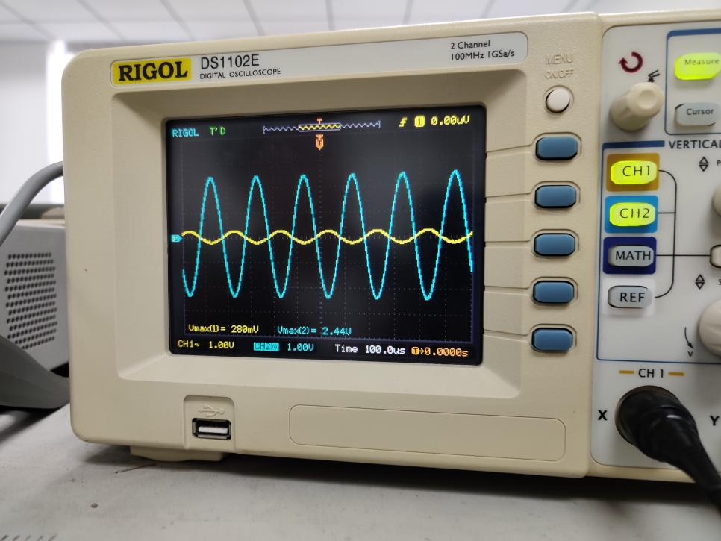

In the diagram, the amplitude of input voltage is 400mV and output voltage is 4.88V. Therefore, the amplification Av is -. For the predicted amplification, Av = So there is little difference between the predicted value and measured value, which proves the common-emitter amplifier’s typical role as an amplifier. Also, the phase agree perfectly in the diagram.

(b) After removing the a.c. input signal, .

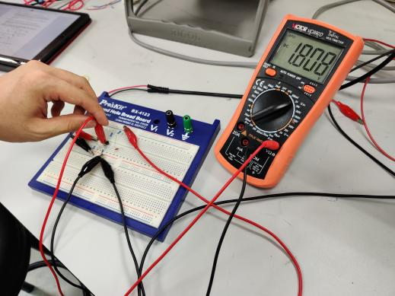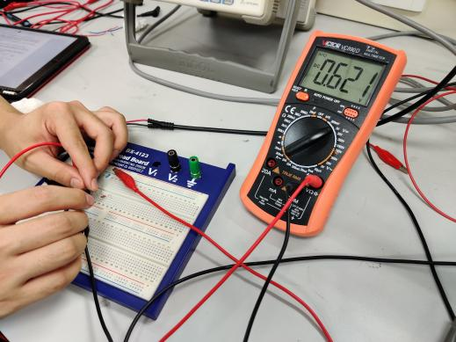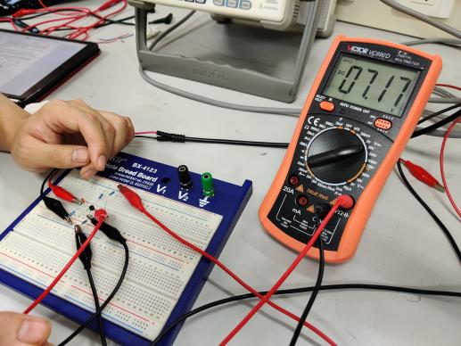

By the simulation of LTspice as shown in figure 8, the predicted values are .

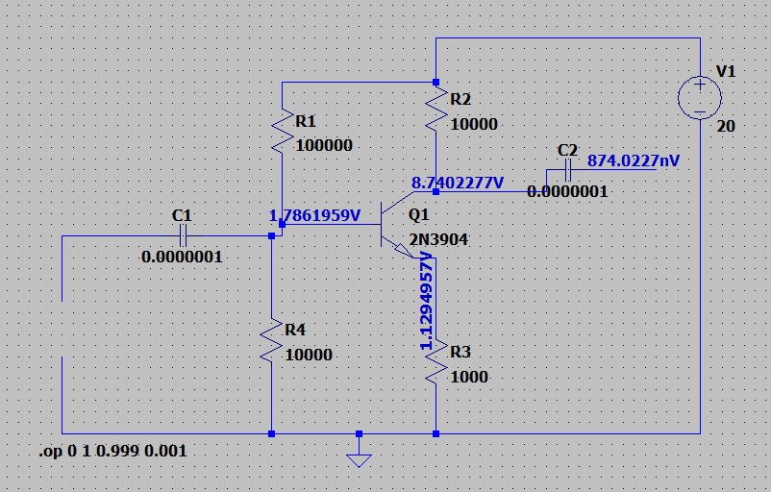

Figure 8 The simulation on the LTspice

Therefore, there is little difference between the predicted values and the measured values.

After introducing the a.c. input signal again, at Vin = 2.4 V, the Vout becomes clipped.

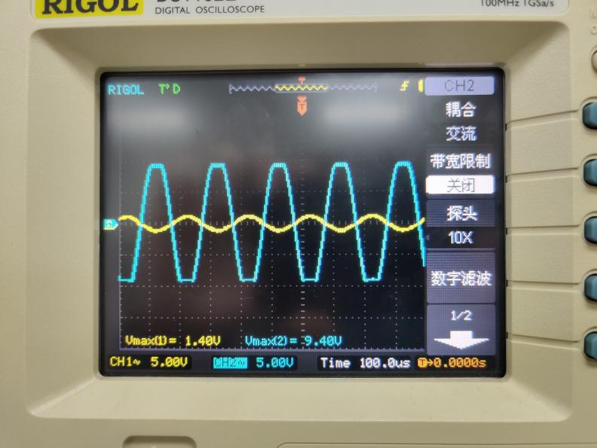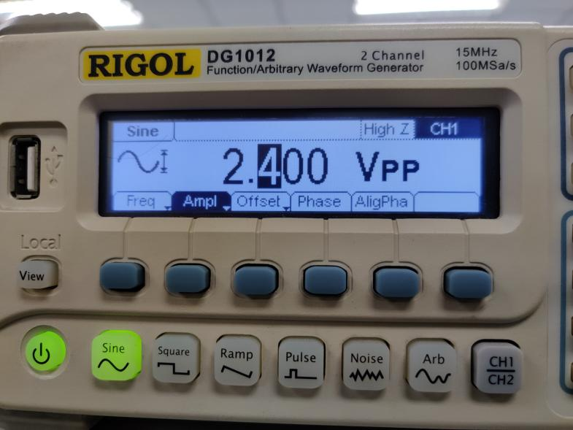

At this point, the amplitude corresponds to 2.4Vpp

When the transistor turns on, and the output voltage is clipped to Therefore, when Vin = 2.4V, Vout becomes clipped.

### Result Discussion

Project achievements:

1. Fully understand the physical structure and operation of the bipolar junction transistor.
2. Make a successful measurement of the input and output characterisitics of a transistor.
3. Successfully design and build a simple common-emitter amplifier.

The outcome of the project is that we finally figured out the input and output characterisitics and common-emitter amplifier role of the transistor, which will help students a lot in the future study, such as the use of the bipolar transistor in linear amplifier applications.

The methodology works well in this project and is applicable to other projects. First, build the circuit; second, regulate the values of components; finally, measure and record the values we need. In other projects such as the experiments on diodes, we also used this methodology, thus proving the applicablity of the methodology.

### Conclusions

In summary, a series of experiments on the transistor are conducted to find the input and output characteristics and common-emitter amplifier role of it. Moreover, the physical structure and operation of the transistor are understood.

There are some experimental errors in the experiment, the reasons we assumed are as follows:

1. Any measuring instrument has a certain accuracy level, and there will be measurement errors.

2. The actual value of any actual component will not remain unchanged, and is affected by temperature, humidity, voltage, and current. For example, the higher the carbon film resistance temperature, the lower the resistance, and the higher the metal film resistance temperature, the greater the resistance.

To improve the accuracy of the experiment, we can use more accurate electronic devices and components of the circuit. Moreover, we should measure more times to get an average value to eliminate the accidental errors.